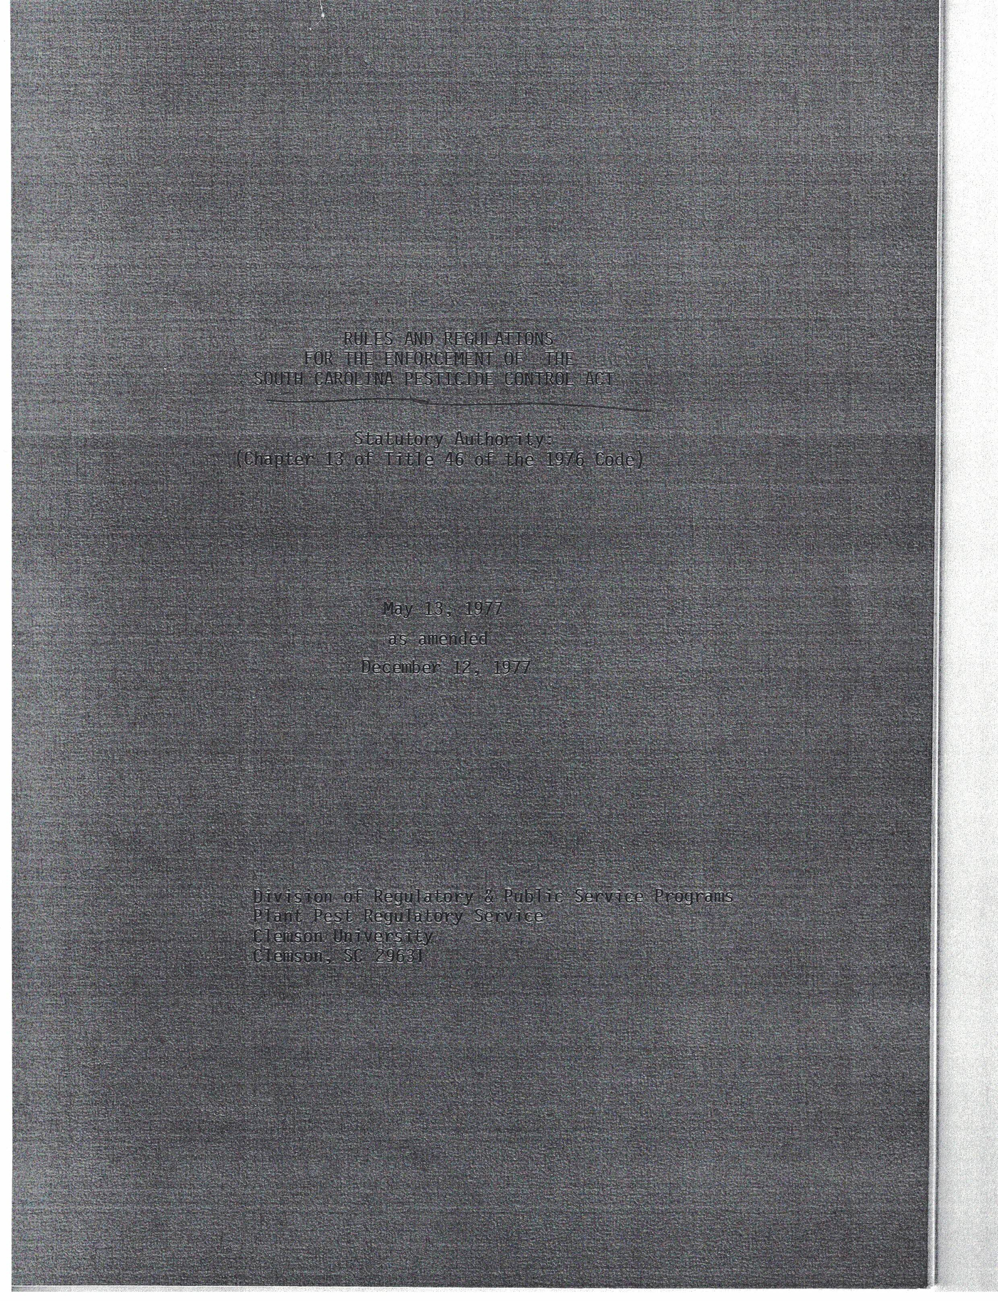

RULES AND REGULATIONS
FOR THE ENFORCEMENT OF THE
SOUTH CAROLINA PESTICIDE CONTROL ACT

Statutory Authority:
(Chapter 13 of Title 46 of the 1976 Code)

May 13, 1977

as amended

December 12, 1977

Division of Regulatory and Public Service Programs
Plant Pest Regulatory Service
Clemson University
Clemson, S.C. 29631

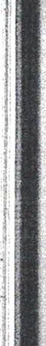
TABLE OF CONTENTS

27-1070 Definitions.................................................................1
27-1071 Registration of Pesticides....................................................1
27-1072 Special Permits 2
27-1073 Coloration and Discoloration 4
27-1074 Pesticide Samples 5
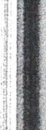
27-1075 Restricted Use Pesticide Classification 6
27-1076 Licensing of Pesticide Dealers and Dealer Records Maintenance 6
27-1077 Certification and Licensing of Private Applicators 8
27-1078 Certification and Licensing of Commercial Applicators 9
27-1079 Certification and Licensing of Noncommercial Applicators....... 14
27-1080 Exemptions from the Requirement of a License and of Certification 15
27-1081 Safe Handling, Storage, Display and Distribution of Pesticides 16
27-1082 Disposal of Pesticides and Pesticide Containers 20
27-1083 Pesticide Application Assurance, Vehicle Identification and
and Applicator Records Maintenance 20
27-1084 Denial, Suspension or Revocation of a License or Certification; Assessment of Criminal Penalties .............................................................. 24

i

RULES AND REGULATIONS FOR THE ENFORCEMENT OF THE
SOUTH CAROLINA PESTICIDE CONTROL ACT
Statutory Authority:
(Chapter 13 of Title 46 of the 1976 Code)

27-1070 Definitions.
A. "Director" means the Director of the Division of Regulatory and I -
Public Service Programs. Clemson University.
B. "Plant Pest Regulatory Service" is a department within the Division of Regulatory and Public Service Programs, Clemson University.
27-1071 Registration of Pesticides.
- Registration. All pesticide products (including products distributed in bulk) except technical grade pesticide material (which is for the express purpose of formulation of pesticide products) and pesticides distributed under an experimental use permit, shall be registered with the State for the period in which the products are offered for sale or distribution within the state. Unregistered products shall be removed from the retailer's shelves; provided, that the Director may allow a reasonable period of time for the retailer to dispose of existing stocks of pesticides after the manufacturer or di stri butor has ceased to register the product with the State. The method of disposal shall be determined by the Director.
- Federal experimental use products. The permittee sha11 notify the Director in writing of each experimental use permit issued under the Federal Insecticide, Fungicide, and Rodenticide Act, as amended, whereunder pesticides are to be used in the State. The notification
1

shall be furnished within thirty days after issuance of the federal permit. A copy of the label accepted by the U. S. Environmental Protection Agency in connection with the permit, a copy of the Experimental Use Permit issued by EPA, and a copy of the EPA letter establishing any relevant temporary tolerances shall also be furnished to the Director with the notification. The Director requires as a minimum: the EPA permit number, information on the locations within the state where the product will be used, the name(s) of the active ingredient(s), the total amount of the pesticide to be applied in the state, the crops or sites involved and the intended purpose.
- Labeling.

  - The State hereby adopts the same requirements for labeling as established by the U. S. Environmental Protection Agency.
  - The Plant Pest Regulatory Service will normally accept a copy of the latest label accepted by the EPA for federal registration of the product, provided the label has been fully corrected with respect
to changes requested by the EPA, and provided the label is in compliance with the labeling requirements in existance at the time the label is submitted to the Plant Pest Regulatory Service.
27-1072 Special Permits.

- Special permits may be granted by the Director for the use of certain pesticides within the State under specific circumstances. These permits will be in the form of either a state registration to meet certain special local needs, or a state experimental use permit to allow the gathering of data needed to obtain a state registration for a special

2
II I'I'

local need.

- State registrations for special needs are authorized under Section 24 (c) of Public Law 92-516, and state experimental use permits are authorized under Section 5 (f) of Public Law 92-516. The Director shall adhere to the requirements established by pertinent federal regulations relative to these two sections when issuing such state registrations or state experimental use permits.
- Basic criteria for initial consideration of products for state registrations and state experimental use permits will be:
  - That there is a special local problem within the state which has created the requirement for the particular new product or for the amended labeling of a registered product and;

  - The essential purpose of the request appears to the Director to be to fulfill the special local need rather than circumvent the normal process of obtaining a federal registration or a federal experi-mental use permit.
- State registrations may be issued for a period of one year, or less if warranted, and shall be subject to the registration fee. State registrations may be renewed annually upon written application to the
Director. These applications will be subject to annual review to ensure
that the request still meets the basic criteria set forth in paragraph C above, as well as federal requirements. State experimental use
permits shall be issued for a specified period of time, are not subject
to a registration fee, and may be extended at the discretion of the
Director.
.I
I
3

27-1073 Coloration and Discoloration.

- The Director shall use the Munsell Book of Color as a color standard.
- White pesticides hereinafter named and white products containing
a substantial quantity of these pesticides shall be colored or dis- f
I
colored in accordance with this section.
.
  - Coloring agent. The coloring agent must produce a uniformly colored product not subject to change beyond the minimum requirements specified in the regulations in this part during ordinary conditions
of marketing or storage and must not cause the product to be ineffect- ive or result in its causing damage to nontarget organisms when used as directed.
  - Arsenicals and barium fluosilicate. Standard lead arsenate, basic lead arsenate, calcium arsenate, magnesium arsenate, zinc arsenate, zinc arsenite, and barium fluosilicate shall be colored any hue, except the yellow-reds and yellows, having a value of not more than 8 and a chroma of not less than 4, or shall be discolored to a neutral lightness value not over 7.
  - Sodium fluoride and sodium fluosilicate. Sodium flouride and sodium fluosilicate shall be colored blue or green having a value of not more than 2 and a chroma of not less than 4, or shall be discolored to a neutral lightness value not over 7.
  - Exceptions.
(a) Notwithstanding the provisions of paragraphs (2) and (3) of
this section, the Director, after opportunity for hearing, may permit

4

other hues to be used for any particular purpose if he determines that use of the prescribed hues is not feasible for such purpose and is not necessary for the protection of health and the environment.

(b) Any pesticide specified in this section which is intended solely for use by a textile manufacturer or commercial laundry, cleaner or dryer as mothproofing agent, and which would not be suitable for such use if colored and which will not come into the hands of the public except when incorporated into a fabric, may be exempted by the Director from the requirements of this section.
(c) The pesticide sodium flouride shall be exempt from the requirements of paragraph (3) of this section when:
(l) It is intended for use as a fungicide solely in the manu- facture or processing of rubber, glue, or leather goods;
- Coloration of the pesticide in accordance with said requirements will be likely to impart objectionable color characteristics to the finished goods;
- The pesticide will not be present in such finished goods in sufficient quantities to cause injury to any person;
- The pesticide will not come into the hands of the public except after incorporation into such finished goods.
27-1074 Pesticide Samples.
- Inspectors and other authorized personnel of the Division of Regulatory and Public Service Programs shall collect official samples of pesticide products manufactured, distributed, sold or held for sale,

5

and, in certain instances, about to be used within the state. The samples will be collected by a standard procedure outlined by the Director, in order to promote uniformity of the samples.
- Samples taken will be analyzed for deficiencies and adulteration, or for other purposes as deemed appropriate by the Director.

- Samples taken and subsequently analyzed may be used as the basis for regulatory action initiated under the provisions of the South Carolina Pesticide Control Act where warranted.
27-1075 Restricted Use Pesticide Classification.

The State may adopt the same list of restricted use pesticides and use patterns established by the U. S. Environmental Protection Agency. If EPA does not establish a list of this nature, then such a list may still be established for the State at the discretion of the Director.
27-1076 Licensing of Pesticide Dealers and Dealer Records Maintenance.

- Age limit. No person younger than eighteen years old will be licensed as a pesticide dealer.
- Pesticide dealers shall pass a written examination, unless already certified as commercial applicators.

- Pesticide dealers shall complete an application form supplied by
the Plant Pest Regulatory Service.

- A fee of twenty-five dollars shall accompany the application.

- The pesticide dealer's license and fees are not a substitute for the restricted use pesticides applicator's license, certification, and

6

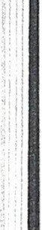
fees. The dealer's license does not allow the licensee to apply restricted use pesticides or allow a reduction of the fees necessary for an applicator's license.

- Pesticide dealer's licenses shall expire on December thirty-
first. Licenses may be renewed annually by application to the Director and payment of the annual fee prior to January first. A twenty-five percent penalty will be charged for renewal applications filed after January first.
Re examination will not be required annually if licenses are renewed before March first. If any license is renewed after March first of each year, such licensee shall be required to take another examination.
- There shall be a separate individual licensed as a dealer for
each store, sales location, or branch salesyard, including multiple sales locations owned by the same person, which sell restricted use pesticides.
- Dealer records maintenance.

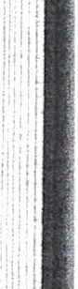
(l) Records shall be maintained by each licensed pesticide dealer on all restricted use pesticides sold. The records shall be maintained on a standard form approved by the Plant Pest Regulatory Service, and these records shall be submitted to the Plant Pest Regulatory Service on a quarterly basis.
- The records shall contain the information requested on the form, which shall be, at the minimum, the date of the sale, the certified applicator's name and license number under whose certification the restricted use pesticide was purchased, the product name, EPA registration number, and the quantity of the restricted use pesticide sold. The dealer shall obtain verification of receipt of the restricted use pesticide

!
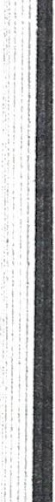
..I
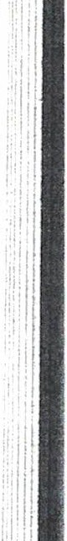
;

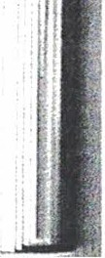
7

from the purchaser.

27-1077 Certification and Licensing of Private Applicators.

  - Age limit. No person younger than fifteen years old will be licensed as a private applicator; however, in hardship cases persons under the age of fifteen may be licensed at the discretion of the
Director.

  - Financial responsibility. Private applicators are not relieved from liability for damage to the person or lands of another caused by the use of pesticides applied by them (or under their direction) even though such use conforms to the rules and regulations promulgated by the Director, and even though they are not required by law to demon- strate the same financial responsibility required of commercial appli- cators.

  - Classification of license. Persons holding a private applicator's license may use or supervise the use of a pesticide which is classified for restricted use, but only for purposes of producing an agricultural commodity, including forestry products, on property owned or rented by
him or his employer or (if applied without compensation other than trading
of personal services between producers of agricultural commodities) on the property of another person.
I
  - Requirements for certification and licensing.

(1) Private applicators shall accomplish all of the following prior to being certified and licensed:
(a) Complete an application form supplied by the Plant Pest

8

Regulatory Service.

(b) Complete a prescribed training program dealing with
pesticides.
(c) Pay a fee of one dollar.

(2) Private applicator licenses shall expire on December thirty first of each year.
(3) Private applicator licenses are renewable annually by reapplication to the Director prior to January first and payment of the one dollar fee. A twenty-five percent penalty will be charged for renewal applications filed after January first. Retraining will not be required annually; however, may be required at times in the future to present information on new pesticides, techniques or other pertinent advances in the various pesticide related sciences.
(4) Persons holding valid commercial and noncommercial applicator licenses, if they desire, may obtain a private applicator's license simply by submitting the proper application form and the one dollar fee to the Director. Additional training is not required.
27-1078 Certification and Licensing of Commercial Applicators.

- Age limit. No person younger than eighteen years old will be licensed as a commercial applicator.
- Financial responsibility.

(1) Pursuant to Section 10 of the Act, commercial applicators shall demonstrate to the Director a minimum financial responsibility of five

9



thousand dollars for property damage and public liability.

(2) If a certified commercial applicator fails to maintain satisfactory evidence of adequate financial responsibility at all times with the Director, it shall result in immediate revocation of his license.
(3) The insurance or surety company shall give at least ten days written notice by certified mail to the Plant Pest Regulatory Service, Clemson University, Clemson, South Carolina 29631 as a condition precedent to the cancellation by the surety or insurer,
material change, or cancellation by the insured; and, if such condition is not satisfied, any cancellation or attempted cancellation shall be null, void, and of no effect.

(4) Furthermore, the above notwithstanding, commercial applicators are still not relieved from liability for damage to the person or lands of another caused by the use of pesticides applied by them (or under their direction) even though such use conforms to the rules and regulations promulgated by the Director.
- Classification of license.

(1) Persons holding a commercial applicator's license may use
. .
restricted use pesticides, but only for work in the specific categories
in which the commercial applicator has demonstrated competence.

(2) Commercial applicator's licenses will be issued for the
following eleven specific categories of commercial pesticide operations:

10

(a) Agricultural pest control
(1)Plant (2)Animal
(b) Forest pest control
(c) Ornamental and Turf pest control
(d) Seed treatment
(e) Aquatic pest control
(f) Right-of-way pest control
(g) Industrial, Institutional, Structural and Health Related pest control
(1) General
(2) Fumigation
(h) Public Health pest control
(i) Regulatory pest control
(j) Demonstration and Research pest control
(k) Aerial Applicator
- Requirements for certification and licensing.
(1) Commercial applicators shall accomplish the following prior to being certified and licensed:

(a) Pass a basic examination, known as the core examination, dealing with the minimum amount of subject matter considered essential to the use of restricted use pesticides.
(b) Pass a separate specific examination on each particular classification category of certification for which the applicant has applied.

(c) Complete an application form supplied by the Plant Pest Regulatory Service.
11

(d) Pay a fee of twenty-five dollars. In instances where more than one commercial applicator works for a commercial firm or an organization and they all work out of the same office location and the firm or organization chooses to pay the license fee for the individuals, then the total fees will be twenty-five dollars for the first individual irrespective of the number of classification cate- gories plus five dollars for each additional individual certified in any one category. An additional fee of five dollars is hereby established for the licensing of all individuals above the initial
licensee, for each classification category above their first category, up to a maximum of twenty-five dollars per person.
(2) Aerial Applicators.

(a) All aerial applicators of pesticides (including transient aircraft pilots) are subject to the same requirements outlined in paragraph D (1) above. All pesticide applicators (including aerial applicators) shall either be certified and licensed by the Plant Pest Regulatory Service or shall work under the direct supervision of a certified licensed applicator in order to apply restricted use pesticides within the State.

(b) The term "Under the Direct Supervision of a Certified Applicator" is hereby expanded. The availability of the certified applicator shall be directly related to the hazard of the situation. In many situations, where the certified applicator is not required to be physically present, "direct supervision" shall include verifiable instruction to the competent person, as follows: (1) detailed guidance for applying the pesticide properly, and (2) provisions for

12

contacting the certified applicator in the event he is needed. In other situations, and as required by the label, the actual physical presence of a certified applicator may be required when application is made by a non-certified applicator.
(c) The term "Contractor", as defined in the regulations of the South Carolina Aeronautics Commission, will be considered equivalent to any other commercial pest control firm or organization, and the contractor may pay the fees for his certified and licensed commercial applicators (aircraft pilots) in accordance with paragraph D (l) (d) above, but only for those pilots who fly aircraft owned by the contractor and who are actually employed by the contractor under
bona fide employment agreements. Pilots who merely use the contractor's facilities and are not bona fide employees of the contractor, and
pilots who fly their own aircraft (if said aircraft is designed or equipped for aerial application of pesticides) on the job for the contractor shall be considered to be self-employed commercial applicators and each shall pay the full twenty-five dollar license fee.
(d) These regulations concerning aerial applicators do not in any way negate the regulations promulgated by the South Carolina Aeronautics Commission.

(3) Commercial applicator licenses shall expire on December thirty-first of each year.
(4) Commercial applicator licenses are renewable annually by reapplication to the Director prior to January first and payment of the annual fee. A twenty-five percent penalty will be charged for
renewal applications filed after January first. Reexamination will not

13

be required annually if licenses are renewed before t1arch first; however, may be required at times in the future if training is offered to present information on new pesticides, techniques, or other pertinent advances in the various pesticide related sciences. If any license is renewed after March first of each year, such licensee shall be required to take another examination.
(5) Commercial applicators holding valid licenses who desire to have a private applicator's license may submit the proper application form and the one dollar fee to the Director. A private
applicator license will be issued with no additional training required.
27-1079 Certification and Licensing of Noncommercial Applicators.
A. Age limit. No person younger than years old will be eighteen licensed as a noncommercial applicator.
B. Financial responsibility. Noncommercial applicators are not
relieved from liability for damage to the person or lands of another
caused by the use of pesticides applied by them (or under their
direction) even though such use conforms to the rules and regulations promulgated by the Director, and even though they are not required by
law to demonstrate the same financial responsibility required of commercial applicators.
C. Classification of license. Persons holding a noncommercial applicator's license may use restricted use pesticides, but only for work in the specific categories, as outlined for commercial applicators, in which the applicator has demonstrated competence. These licenses are issued to permit various qualified governmental employees to
14

perform their official duties on the job without payment of a fee.

D. Requirements for certification and licensing.

(1) Noncommercial applicators shall submit an application form supplied by the Plant Pest Regulatory Service, and shall pass the same set of examinations required of the commercial applicators.
(2) Noncommercial applicators are exempt from the fee requirements imposed on commercial applicators.

(3) Noncommercial applicators' licenses shall expire on December thirty-first of each year.

(4) Noncommercial applicators' licenses are renewable annually by reapplication to the Director prior to January first. Reexamination will not be required annually if licenses are renewed before March first; however, may be required at times in the future to present information on new pesticides, techniques, or other pertinent advances in the various pesticide related sciences. If any license is renewed after March first of each year, such licensee shall be required to take another examination.

(5) Noncommercial applicators holding valid licenses who desire 'I
to have a private applicator's license may submit the proper application form and the one dollar fee to the Director. A private applicator license will be issued with no additional training required.
27-1080 Exemptions from the Requirement of a License and of Certification.

- Doctors of veterinary medicine applying pesticides to animals

l5

during the normal course of their practice are exempt from the requirements of certification and licensing; provided, they are not regularly engaged in the business of applying pesticides for hire as a principal or regular occupation.
- Medical personnel (both private and government) applying pesticides to man during the normal course of medical practice are exempt from the requirements of certification and licensing.
27-1081 Safe Handling, Storage, Display and Distribution of Pesticides.

- Sales of pesticides which have been classified for restricted use shall be made only to the following:
  - Licensed pesticide dealers;

  - Licensed certified applicators;

  - Persons exempt from the requirements of licensing and certification.
- Storage of pesticides in quantity (both general use (except as listed in paragraph D below) and restricted use items) by wholesalers, dealers and retailers.
  - All pesticides stored in quantity shall be stored in well ventilated rooms, well away from all food or feed items. The pesticides should be stored in such manner as to prevent fumes from contaminating food or feed.
  - Pesticides should be separated during storage, preferably in bins, depending upon the type of pesticide. Each type of pesticide,

16

i.e., herbicides, insecticides, fungicides, et cetera, should be stored separately from each other.
  - Herbicides shall not be stored in a bin on top of, or located above, any other type of pesticide, to preclude accidental contamination of other pesticides by leakage or spillage.
- Display of pesticides (both general use and restricted use items) by dealers and retailers.
  - All pesticides offered for sale shall be in the registrant's original container.
  - All restricted use pesticides shall be separated from general use pesticides in displays of pesticides offered for sale to the general public.
  - Herbicides shall be separated from all other types of pesticides when displayed for sale to the general public . Furthermore, herbicides shall not be displayed in a position above other types of pesticides,
to preclude accidental contamination of other pesticides by leakage or spillage.
  - All pesticides (either general use (except as listed in paragraph D below) or restricted use items) on display to the general public, should be displayed at a minimum distance of twenty-five feet from all fresh, soft, loosely packaged or other types of food or feed items that can or may absorb odors from the pesticides. Examples of such food items would be bread, pastries, potatoes, fresh meats, cheese, macaroni and candy. All pesticides shall be displayed at a minimum distance of four feet from canned foods or any other type of food or

17

edible item.

- Exemptions to the storage and display requirements.

( 1 ) The following types of pesticides are exempt (unless classified as restricted use pesticides) from storage and display requirements of paragraphs B and C(2) through C(4) above. They are still subject to the requirement of paragraph C(1) above.
  - Bleach products

  - Disinfectant products

  - Pet animal and tropical fish treatment products

  - Sink drain and toilet bowl products

  - Paint products

(2) Additional exemptions may be granted by the Director upon special request, if warranted.
- Aircraft loading zones.

  - All aircraft pesticide loading zones shall be adequately
delimited and posted as a general warning to the public that toxic and dangerous pesticides (or their empty containers) may be stored in the area, and especially that pesticides may have been spilled on the ground in the area.
  - Conformance with the requirements of paragraph E (1) above does not relieve any person from liability for injury or damage to another person caused by the pesticides, either while being stored or

18

after spillage on the ground.

- Bulk distribution and storage of pesticides.

  - All pesticides distributed in bulk shall be registered both with the U. S. Environmental Protection Agency and with the State. Furthermore, any firm distributing or selling bulk pesticides within the State shall notify the Plant Pest Regulatory Service of such practice on January first of each year.
  - A copy of the accepted label for the product shall be attached to the shipping papers, and left with the consignee at the time of delivery.
  - Pesticide products stored in bulk containers, whether mobile or stationary, which remain in the custody of the user, shall bear a copy of the accepted label or labeling, including all appropriate directions for use, securely attached to the container in the immediate vicinity of the discharge control valve.

  - The appropriate provisions of 49 CFR Parts 1 70-189, administered by the U. S. Department of Transportation, concerning the transportation of hazardous materials, shall be adhered to by any person transporting pesticide products within the State.
  - All containers (both holding tanks of formulator and customers' stationary containers) shall be provided with suitable sample points to permit withdrawal of samples by personnel of the Plant Pest Regulatory Service; such samples to be accepted, without reservation, as being representative of the material therein and described on the label attached.
19

27-1082 Disposal of Pesticides and Pesticide Containers.

Unwanted pesticides and pesticide containers shall be disposed of in accordance with the regulations promulgated by the South Carolina Department of Health and Environmental Control.
27-1083 Pesticide Application Assurance, Vehicle Identification and Applicator Records Maintenance.
- Pesticide applicator assurance. The following is hereby required of all licensed commercial pesticide applicators during certain phases
of their commercial operations.

- Structural and general household pest control operations.

  - Provide all customers with a completed, fully legible, statement with respect to any application of restricted use pesticides.
  - The statement shall contain the following information, as a minimum:
(1) Company or firm name and address.

(2) The pest or pests to be controlled.

(3) The chemical or common name of the active ingredient(s) (not the brand name) of the restricted use pesticide applied.
(4) Name of responsible licensed applicator.

  - Requirements of paragraph A(1)(b) above may be modified, per the next sentence, for operations which are limited to general household insect control for cockroaches, ants, fleas, ticks, stored

20

products insects, centipedes, spiders, et cetera, or rats and mice, either for residential or commercial type operations, if the service is being performed under a routine yearly service contract. If under a yearly contract, then more general terms may be used relative to the name of the pest and several alternate chemicals may be listed.
The requirements are still in effect for structural pest control operations, and for wood boring insects of any kind. Also, all require- ments for record maintenance still apply.
- Aerial applicators.
  - Provide all customers with a completed, fully legible, statement with respect to any application of restricted use pesticides.
  - The statement shall contain the following information, as a minimum:
(1) Company or firm name and address.
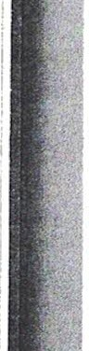
(2) The pest or pests to be controlled, or purpose of the pesticide application.
(3) The chemical or common name of the active ingredient(s) (not the brand name) of the restricted use pesticide applied.
(4) Name of responsible licensed applicator.

(3) Custom ground applicators. (This group includes commercial agricultural applicators, lawn and golf course, ornamental plant and tree pesticide applicators, mosquito control pesticide applicators, wood preservative applicators, and all other types of commercial pesticide applicators.)

21

(a) Provide all customers with a completed, fully legible, statement with respect to any application of restricted use pesticides.
(b) The statement shall contain the following information, as a minimum:
(1) Company or firm name and address.

(2) The pest or pests to be controlled, or purpose of the pesticide application.
(3) The chemical or common name of the active ingredient(s) (not the brand name) of the restricted use pesticide applied.
(4) Name of responsible licensed applicator.

- Vehicle identification; All land vehicles and boats used by licensed commercial pesticide applicators to transport restricted use pesticides to and from the application site, or used in the actual application of restricted use pesticides, shall bear an identification symbol, furnished by the Plant Pest Regulatory Service, on both the right and left sides of the vehicle or boat. This requirement also applies to tractor drawn spray equipment or to large self-propelled spray equipment used by the commercial applicator. [Aircraft will be identified by their registration number; therefore, will not be required to bear the state identification symbol.]
  - The symbol shall be maintained clean and recognizable from a minimum distance of one hundred feet.
  - State identification symbols are not required on every piece of

22
small equipment used by a licensed applicator, nor on every automobile or truck owned by a company, firm, or applicator. Symbols are required only on the actual transport, service and application vehicles.
- Applicator records maintenance.
  - Records shall be maintained by each company or firm using restricted use pesticides through a licensed commercial applicator, or by each licensed commercial applicator if self-employed, and by each licensed noncommercial applicator, of all restricted use pesticides used.
  - The record shall include the quantity of each restricted use µesticide used, the chemical or common name of the active pesticidal ingredient(s) (not the product name), the pest or purpose for which the pesticide was applied, and the date and place of application. It will not be necessary to list the pests involved for general household insect control or for general insect control measures in commercial and industrial establishments. In these cases the record may indicate merely "household pests" or "general insect control".
  - The above records shall be maintained by the company, firm, or licensed commercial or noncommercial applicator for a period of two years, and shall be made available to the Director or his designee upon written request.
  - Each company, firm, or licensed commercial or noncommercial applicator whose normal location of business is outside the State shall submit a report, on letterhead paper, to the Plant Pest Regulatory Service, listing the recorded information required to be maintained by paragraphs C (1) and C (2) above, on all restricted use pesticides applied in the State by the firm or commercial or noncommercial
23

applicator.
(a) This reporting requirement shall apply to out-of-state aerial applicators as well as to firms or persons performing occasional pest control operations within the state.
(b) The report shall be submitted by calendar quarters, within thirty days after the end of each quarter, for and only for any
quarter in which restricted use pesticides were applied within the state; provided, that aerial applicators performing seasonal agricultural type operations may submit their complete report for the season not later
than November 30 of that year.

27-1084 Denial, Suspension or Revocation of a License or Certification; Assessment of Crimina1 Penalties.
- Each of the following acts shall be considered a violation of the South Carolina Pesticide Control Act, in addition to those mentioned in the Act, and shall constitute grounds for denial, suspension or revocation of a license or certification:
  - Use of a pesticide that is inconsistent with the labeling of the U.S. Environmental Protection Agency or the South Carolina state registration for that pesticide. The term "use'' shall have the same broad meaning, including application, mixing, loading, storage and disposal, as that defined in 40 C.F.R. § 162.3(oo);
  - Making false, fraudulent or inadequate records, invoices or reports, or failure to keep required records;
(3 ) Committing an act resulting in assessment of a civil or criminal penalty under 7 U.S.C. 136-1., as amended.
- Any person who commits any of the above acts shall be deemed guilty of a misdemeanor and criminal penalties may be assessed pursuant to Section 18 of the South Carolina Pesticide Control Act.
24

